**1.Introduction :**

An index of economic freedom compares the jurisdictions against each other for various aspects, such as trade freedom, judicial effectiveness, and tax burden. These factors may be weighed for their influence on economic freedom and collated into a single score for ranking

**1.1 Overview:**

An overview of index of economic freedom is a composite measure of the quality of political-economic institutions across different jurisdictions. Scores and ranks in an index are based on criteria that the creators of the index judge as being relevant, which vary from one index to another.

**1.2 Purpose:**

Economic freedom means that people can engage in trade with any person of their choosing. If the government taxes or otherwise prevents people from buying or selling with people in other countries, it reduces their freedom.

**PROBLEM DESINATION AND DESIGN THINKING**

**2.1 EMPATHY MAP**



**2.2 BRAINSTROM**

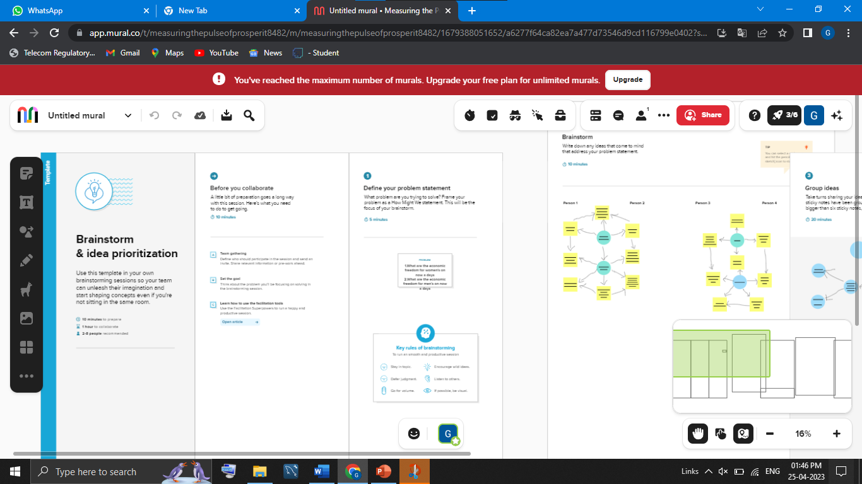

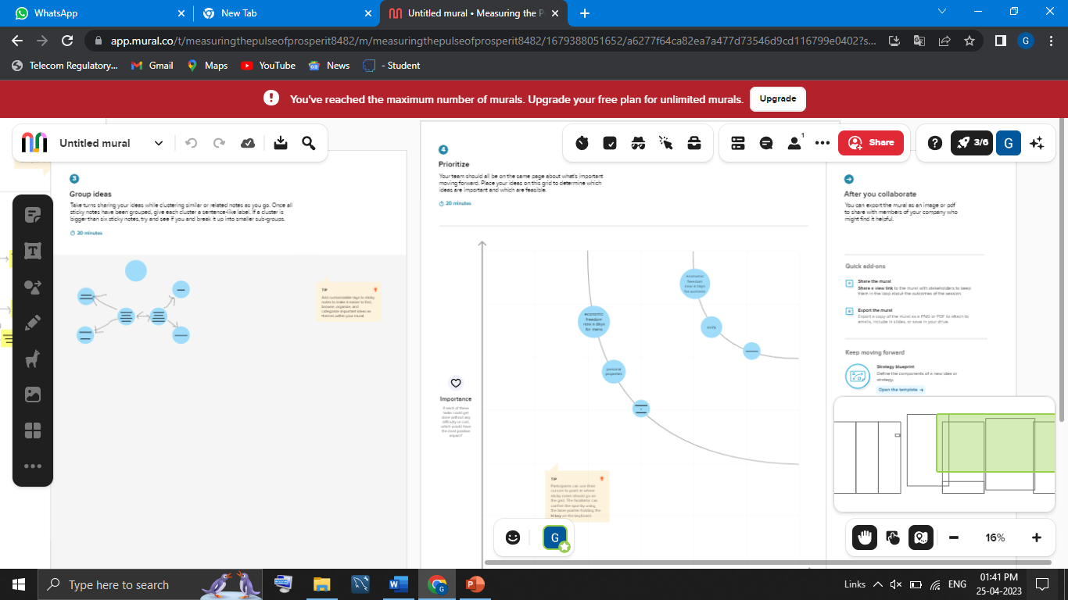

**3.RESULT:**

Economic Freedom Index: Overview, Methodology and Rankings

The Index of Economic Freedom is an annual index published and created by the Heritage Foundation and the Wall Street Journal to measure economic freedom.

**DASHBOARD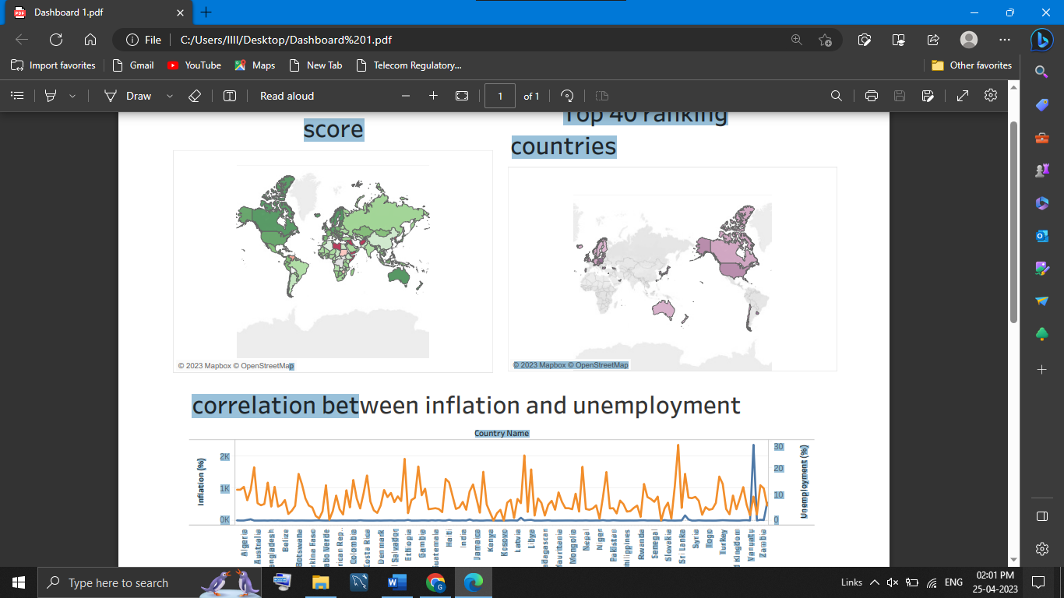ARD**

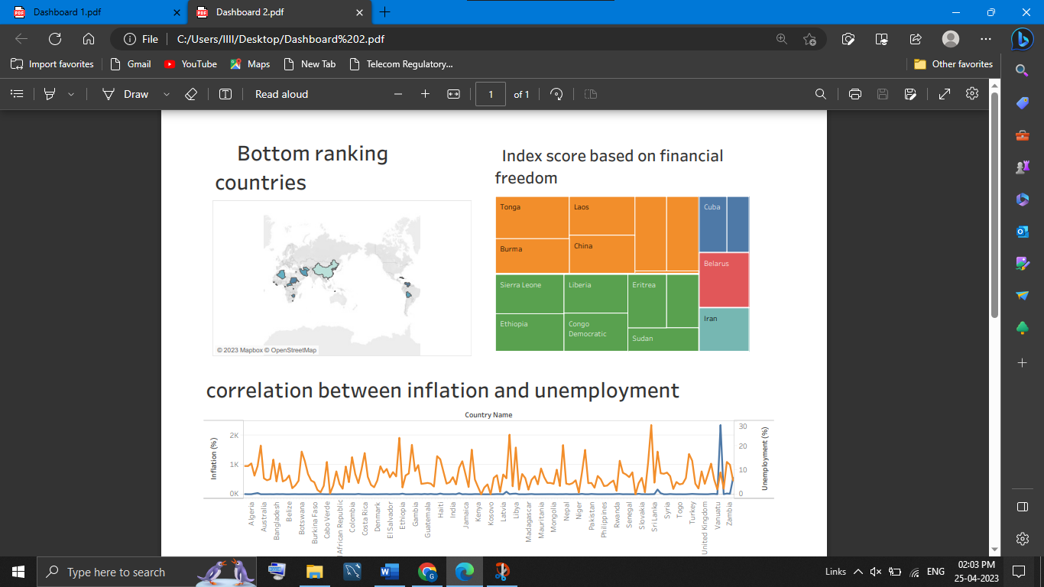

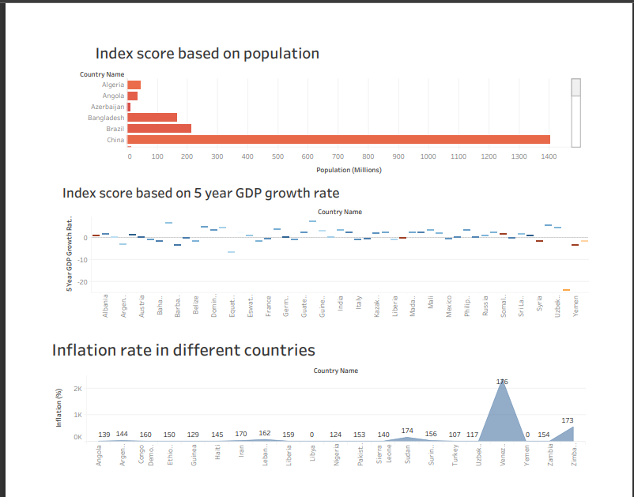

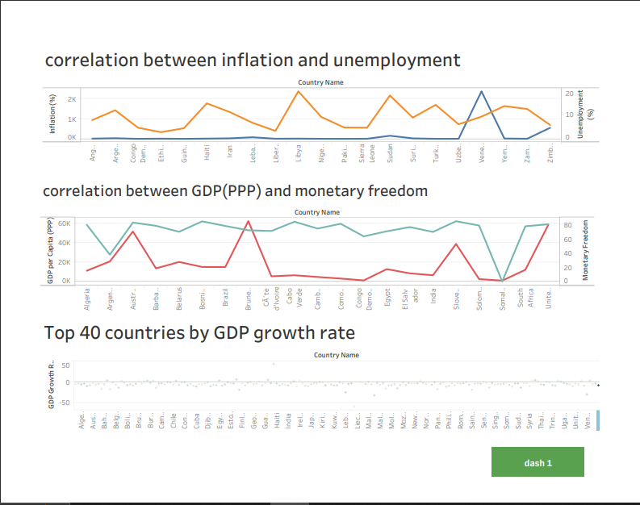

**STORY BOARD**

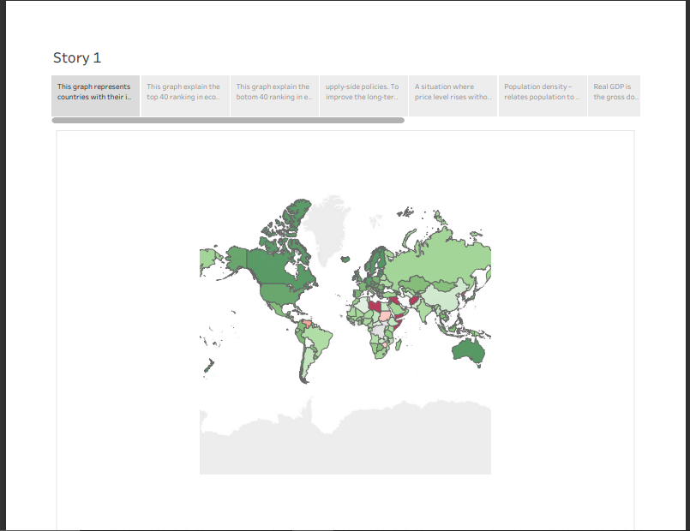

**TABLEAU PUBLIC:**

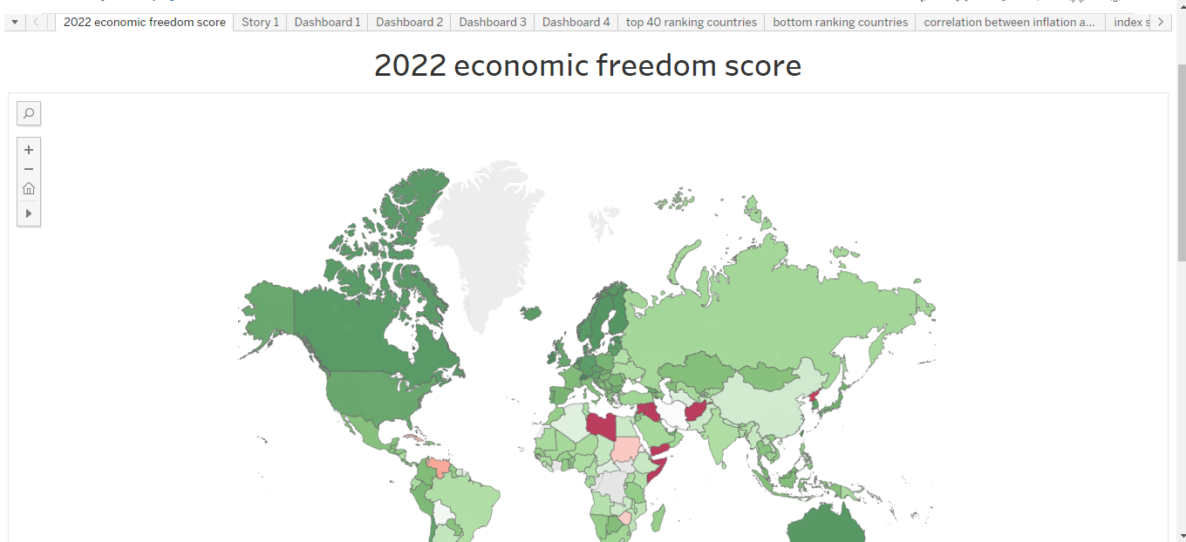

**4.ADVANTAGES**

* The most obvious benefit of economic freedom is that, as a system, it is the most conducive to widespread prosperity, that is, to high or rising income and consumption for the bulk of the population.
* There is a positive correlation between economic freedom and a country's overall prosperity and growth rate due to economic development. Free countries with market economies tend to have a greater wealth per capita, cleaner environments, higher life expectancy, and less poverty.
* An economic advantage is a position or capability that allows you to outperform in a particular market. It's a similar concept to competitive advantage but at the level of economic fundamentals

**DISADVANTAGES**

* Poor Quality. Since profit maximization is the biggest motivation for firms, they may try to reduce their costs unethically. ...
* Merit Goods. Goods and services that are not profitable will not be produced or run. ...
* Excessive Power of Firms. ...
* Unemployment and Inequality.

**5.APPLICATIONS**

* A market economy has freedom of choice and free enterprise. Private entrepreneurs are free to get and use resources and use them to produce goods and services. They are free to sell these goods and services in markets of their choice.
* Since 1996, the Economic Freedom of the World (EFW) reports have presented an index that measures the consistency of a nation's policies and institutions with economic freedom. The key ingredients of economic freedom are personal choice, voluntaryexchange, freedom to compete, and protection of person and property.

here is a positive correlation between economic freedom and a country's overall prosperity and growth rate due to economic development. Free countries with market economies tend to have a greater wealth per capita, cleaner environments, higher life expectancy, and less poverty

**6.CONCLUSION**

The key ingredients of economic freedom are personal choice, voluntary exchange, freedom to compete in markets, and protection of person and property. Institutions and policies are consistent with economic freedom when they allow voluntary exchange and protect individuals and their property**.**

**7.FUTURE SCOPE:**

As time goes on, these measures of economic freedom will improve and our understanding of the relationship between private property and free markets and economic performance will similarly improve. But in the great debate between economic freedom and political planning, the evidence is increasingly clear. Economic freedom leads to better economic results.